(Approx. 781 words)

Customizing Your Windows 11 Desktop
by Tom Burt, Vice President
Sun City Summerlin Computer Club
https://www.scscc.club
tomburt89134 ** cox.net

Introduction

Windows 11 usage steadily increases as more users upgrade from Windows 10 or buy a new PC with Windows 11 pre-installed. This article will offer a few configuration options for making the Windows 11 desktop more to your liking. We’ll touch on various settings, mainly in the Personalization area.

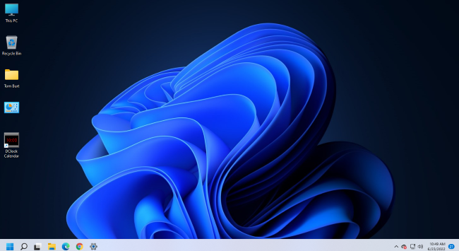

Tom Burt’s Windows 11 Desktop

Choosing a Theme

The default theme is “Windows Light.” PCs from commercial vendors like HP, Lenovo, or Dell may have customized this. Click the “Settings” gear icon on the Start menu and choose Personalization > Themes. The Themes settings screen will display (see screenshot below).

It shows your current theme along with any customizations. Note that a Theme includes colors, images, sounds, and mouse cursor settings. When you have adjusted all the related settings, you can Save those settings as a named custom Theme.

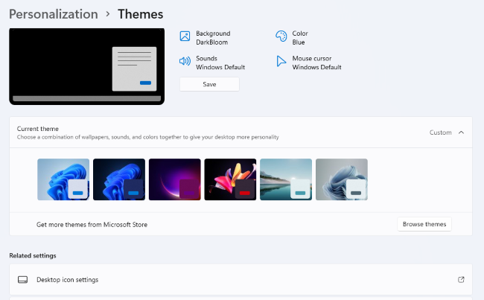

Themes Settings

Windows 11 offers six default Themes. Hover the mouse over each to see the name and behavior. Some Themes rotate between several background images. I decided to keep the default “Windows Light” theme and then customize it.

Choosing Desktop Icons

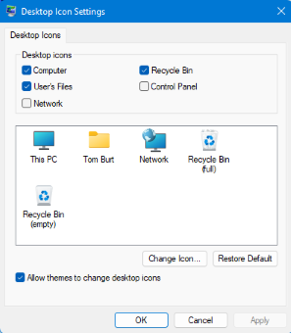
On the main Themes settings, under “Related settings,” is a link for “Desktop icon settings.” Click this to bring up the dialog to the left.

You can click the checkboxes to specify which icons you want to appear on your desktop.

The central panel shows how each icon will appear. You can select an icon and click the “Change Icon” button to open an icon chooser dialog. In addition, you can click the “Restore Default” button to revert an icon to the Windows default.

Unchecking the “Allow themes to change desktop icons” checkbox will retain your desktop icon settings if you decide to change to a different theme.

Choosing a Desktop Background

My next Desktop customization was to select a different background wallpaper. I liked the blue bloom but preferred it on the dark background used in the “Windows Dark” Theme. So I Googled for the location of the images for Windows 11 themes and found the blue bloom on a dark background in C:\Windows\Web\Wallpaper\Windows, named “img19.jpg”.

I copied this image to my Photos\Saved Pictures folder and renamed it “DarkBloom.jpg.” I then went to Settings > Personalization > Background and set the dropdown to “Picture,” and clicked the “Browse photos” button. Next, I browsed to Pictures\Saved Pictures and selected my DarkBloom.jpg image. That set my background to the desired Dark Bloom.

You can set the Desktop background to a solid color, a single image, or a rotating slide show. Knock yourself out!

Choosing Colors

My next Desktop customization was to change some of the color settings. I went to Settings > Personalization > Colors. This opened the screen partially shown below.

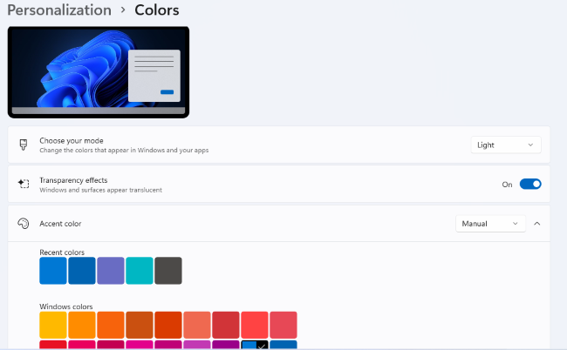

Colors Settings

I left the Mode (Light) and “Transparency effects” settings (On) as they were. I set the Accent color mode to Manual and then chose a medium blue from the palette. I could have created a custom color if I didn’t like any of the palette’s colors.

Next, I scrolled further down until I saw a slider button for “Show accent color on title bars and windows borders.” I clicked to turn this On.

More Colors Settings

Configuring the Taskbar

My next Desktop customization was to set up the Taskbar. I visited Settings > Personalization > Taskbar to bring up the settings screen.

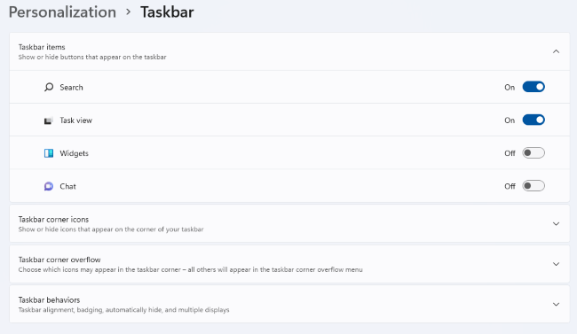

Taskbar Settings

I turned on the sliders for Search and “Task view” and turned off Widgets and Chat. Under the Taskbar corner icons (Pen menu, Touch keyboard, and Virtual touchpad), I left them all Off.

I next clicked the down chevron to open the “Taskbar corner overflow” settings. The Taskbar corner was formerly known as the Notification area and the Windows Tray. Next, I turned on the Microsoft OneDrive and Windows Update Status icons to make them visible. The others appear in the overflow popup.

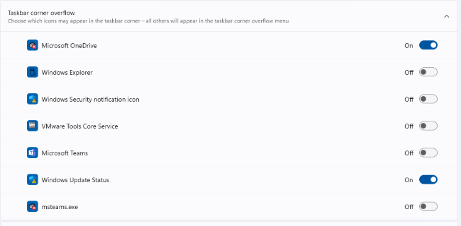

Taskbar Corner Overflow Settings

Lastly, I clicked the down chevron to open the “Taskbar behaviors” settings.

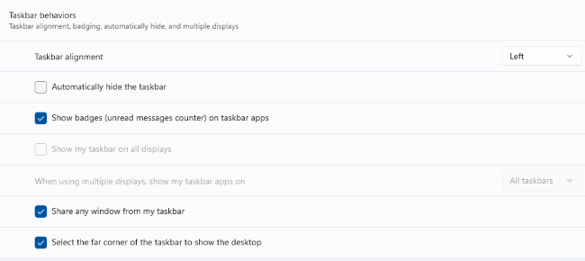

Taskbar Behaviors Settings

For Taskbar alignment, I selected Left from the dropdown. The default is Center. I left unchecked the “Automatically hide the taskbar” and left checked the “Show badges (unread messages counter) on taskbar apps.

Adding Shortcuts to Programs

Use the File Explorer to browse the program’s .exe file (usually in Program Files or Program Files (x86). Left-click to select the .exe file and press Shift + F10 to bring up a context menu. Hover the Mouse over the “Send to” menu option and wait for a secondary menu to appear. Then click “Desktop (create shortcut).” Finally, rename the new Desktop shortcut to suit.

